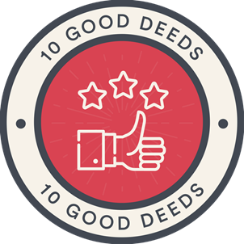 | Being part of a strong and caring community from an early age will help all our pupils to appreciate that giving and supporting others can make their lives more enjoyable and rewarding. Seeing other people smile or benefit from kind gestures will be immeasurable. Through the delivery of 10 good deeds, we want all our children to identify what is needed in their local communities and to work with their peers, parents and neighbours to bring these activities to life.  Although this promise concludes after the 10th deed is done, we hope that this experience encourages all our children to continue to support their communities and enjoy the life-long benefits that this can bring.  Throughout our schools we are committed to providing many thousands of voluntary hours, ensuring we play our part in improving community life beyond our educational responsibilities. We want to be known as outward-facing providers who care about our communities and can make a long-lasting difference
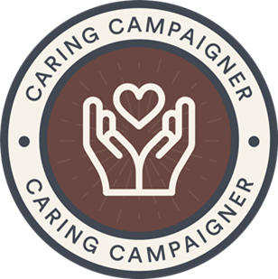 | We want our children to have a built-in sense of curiosity, inquisitiveness and fairness. Recognising the smaller or larger injustices in the world plays an important part in the development of compassion, empathy and responsibility.  Caring Campaigner hones into a child's natural awareness of what is and isn't fair; encouraging the passion to right a wrong, however challenging that might be. It is about recognising that every child has a voice that should be heard and that however young they are- we should listen.  Coupled with a chance to learn documentary filmmaking skills, as well as putting on a film premier in their school setting- this promise is an opportunity for local collaboration and for building strong relationships within the surrounding community of the school.

 | Although some people don’t realise it, art plays an important and continual part in our everyday lives. It is delivered through many different ways and serves many different purposes. It can be used to communicate an important message, to celebrate an occasion or a person, or simply it can be used to generate enjoyment.  Some art is presented on a canvas, others through sculpture. Art can also be delivered through film or animation. What matters is why it is developed.  We want all our pupils to think about what art means to them and how they can use it to express themselves. Through this promise, we want to challenge our pupils to think creatively, source materials and develop their own works of art. To make this truly memorable we want pupils to work in teams to develop memorable legacies that lives with them during their school experience.  Across our Trust, we want to ensure that being artistic is seen as an important and valuable quality. We want to celebrate this and build a reputation for unlocking our artistic potential.
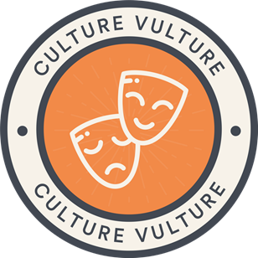 | Within our communities, there is so much talent that we can go seek out and find. Every city, town and village will have unique, cultural experiences at their fingertips- if we only reach out and explore. This is precisely what the Culture Vulture promise is for.  Like the vulture scanning from the skies looking for its next meal, let's go hunting for new cultural experiences for our children close by. From the local choirs, orchestras, brass bands, amateur dramatic groups to cultural dance groups, pop-up galleries and museums and many, many more- a wealth of exciting, enlightening delights are waiting just around the corner for you to find.  To hear a piece of classical music played live really is a wonderful life experience and many local musicians will relish the opportunity for a fresh audience to play to. Culture Vulture is designed to make meaningful community links bringing people from different backgrounds into our children's lives. Whether it's looking at a beautiful piece of art in a gallery or watching a dance from different culture- this promise is there to inspire and evoke passions.

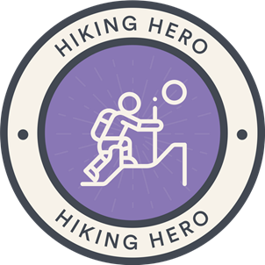 | Many of our pupils will not get regular opportunities to enjoy the great outdoors, nor will they have the thrill or challenge of climbing a peak. Through our Hiking Heroes promise, we want to show how exercise outdoors can be enjoyable and rewarding. We also want all our pupils to realise that this sort of activity might be difficult and challenging but can be well worth the effort.  This promise can also provide great educational benefit. It allows our children to plan a route, to map read, and to think about the provisions that they may need.
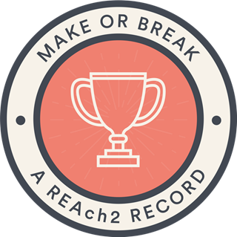 | Throughout life our pupils will face many challenges, some of which will be in competitive environments. It is important that all our pupils have the confidence and skills to tackle these challenges and the opportunities to appreciate and enjoy the feelings of success in relation to their efforts.  The delivery of make or break a record is designed to stretch our pupils’ imagination, and to open their eyes to the wealth of opportunities on offer in their future lives. We want all our children to dare to be different and to realise their dreams.  We will use this promise to create effective camaraderie, communication and excitement amongst our schools. In addition, make or break a record will provide all our pupils with an opportunity to develop their own legacy within the REAch2 family.  To build excitement, we will produce and promote the REAch2 book of records, exploring mind-blowing feats and record-breaking wonders that showcase the amazing individuals and groups of children who attend our schools. In years to come we want to be known for pushing the boundaries and achieving the unexpected.

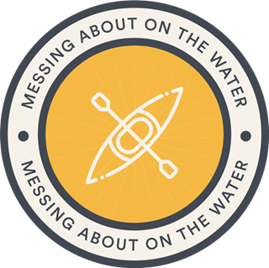 | Being confident in and around water is a vital life skill. In addition to keeping children safe it also unlocks a world of exciting new opportunities and challenges. Through our Messing Around on the Water promise we want to give all our pupils the opportunity to experience new activities and to test themselves in ways they might not have imagined.  In addition to the personal benefits, this promise gives our children the ideal opportunities to support and encourage their friends who might be less confident. This promise is an introduction to the thrill and enjoyment of water sports, allowing children to test their courage on the water and hopefully develop a lifelong love of water sports.
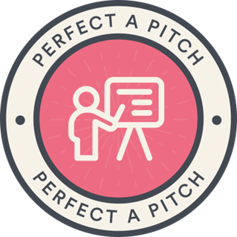 | We feel giving children the opportunity to build entrepreneurial skills from a young age is of huge importance. Learning about what goes into creating a product from concept to costings to promotion and delivery are invaluable and give children a chance to develop life skills in preparation for adulthood.  'Perfect a Pitch' is a chance to make real life purposeful curriculum links with Maths, writing and design and technology and gives children a platform to learn about profit, loss, marketing, packaging and promotion. It also develops speaking and listening skills as the children will present their product and create a meaningful pitch with an actual outcome for their efforts.  This promise creates links with local businesses who will listen to the pitches, decide a winner and agree to sell the product for the financial benefit of both the business and the school.

 | There has never been a clearer message to look after our planet than there is now and this can start in our own playgrounds, fields and gardens. Conservation for all living things is something that children should learn from a young age. Instilling a sense of responsibility for all the creatures we share this planet with can start with the simplest of tasks locally but come with the huge rewards of encouraging strong sense of self-awareness and reflection.  We want to deliberately inspire a fighting spirit for the planet within this generation of children; creating warriors ready to go into battle to save the habitats and environments around them with passion and vigour. There are many national campaigns such as RSPB Garden Watch, The Big Bee Challenge, National Trust and RHS initiatives to name few for schools to pair up with, gain resources and knowledge from to help bring conservation to the forefront and be a focal point to the local community.
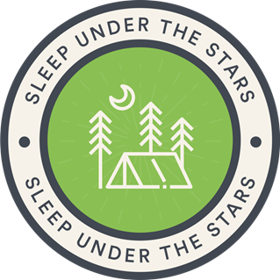 | Looking up at a starry night sky is probably one of the most magical things that children can do. Every person at some point in their life will have thought what it would be like to go into space and wonder what exists beyond our planet. We want all REAch2 children to unlock their adventurous spirit and to be curious about truly spectacular things.  Spending the night away from home with friends will represent one of the most exciting things many children would have done, particularly with sleeping outdoors. Combining the two things together has the potential to deliver a truly memorable experience.  In addition to the excitement of this experience, this promise also provides a great learning opportunity which might unlock a hidden interest in sciences which could in turn stimulate new life ambitions.

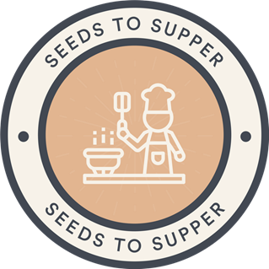 | A good diet is key to a healthy life. We want all our pupils to understand how food is grown and how lovely fresh food is to eat. We want our children to understand the nutritional value of food and what makes a good healthy diet. We want REAch2 pupils to try new foods and be curious and inquisitive about the foods of different cultures.  Having grown their own food it’s important that our pupils to have the skills to prepare their own meals and the confidence to avoid processed pre-prepared meals. We want to engender and develop an enjoyment of cooking.  Throughout our schools we understand the value of children eating well. A healthy diet helps with energy, concentration happiness and health. We want all our pupils to enjoy this advantage within their lives. Whilst in the first instance the Seeds to Supper promise will help our pupils cook their own meals we also hope it will play apart within our 10 good deeds promise.

